SIMATS ENGINEERING
ASSESSMENT TOOL 2 – COMPUTER NETWORKS
(CSA07)
Industry Problem-Solving Task – Question 5

Question 5
Design a network for a company with multiple departments using switches and routers. Each department should be connected through dedicated Layer 2 switches, while a central Layer 3 switch or router enables inter-department communication through VLANs and inter-VLAN routing. The design should provide security, efficient IP addressing, reliability, and scalability.

1. Problem Analysis
A company with HR, Finance, Sales, and IT departments requires controlled communication between departments. If every computer is placed in one broadcast domain, unnecessary broadcast traffic increases and sensitive departments cannot be logically isolated. The proposed solution uses VLANs to separate departments, Layer 2 access switches to connect end devices, and a Layer 3 core switch/router to perform inter-VLAN routing. A router/firewall provides controlled access to external networks.

2. Proposed Network Design
The design follows a hierarchical architecture. Each department has a dedicated access switch. The access switches connect to a central multilayer switch. VLAN 10 is assigned to HR, VLAN 20 to Finance, VLAN 30 to Sales, and VLAN 40 to IT. Trunk links carry multiple VLANs. The Layer 3 gateway provides communication between VLANs. The addressing scheme uses a separate /24 subnet for each department.
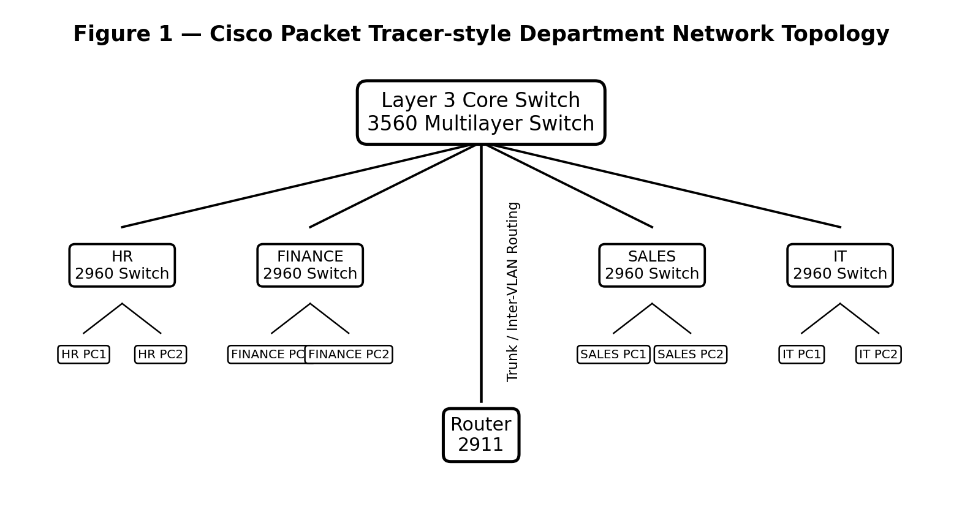
Note: The figures in this document are Packet Tracer-style illustrative diagrams. For your final submission, take screenshots from your own Cisco Packet Tracer file after performing the steps below.

3. VLAN and IP Addressing Plan
The following addressing plan keeps each department in a separate broadcast domain.
VLAN | Department | Network | Default Gateway | Example PC IP
10 | HR | 192.168.10.0/24 | 192.168.10.1 | 192.168.10.10
20 | Finance | 192.168.20.0/24 | 192.168.20.1 | 192.168.20.10
30 | Sales | 192.168.30.0/24 | 192.168.30.1 | 192.168.30.10
40 | IT | 192.168.40.0/24 | 192.168.40.1 | 192.168.40.10
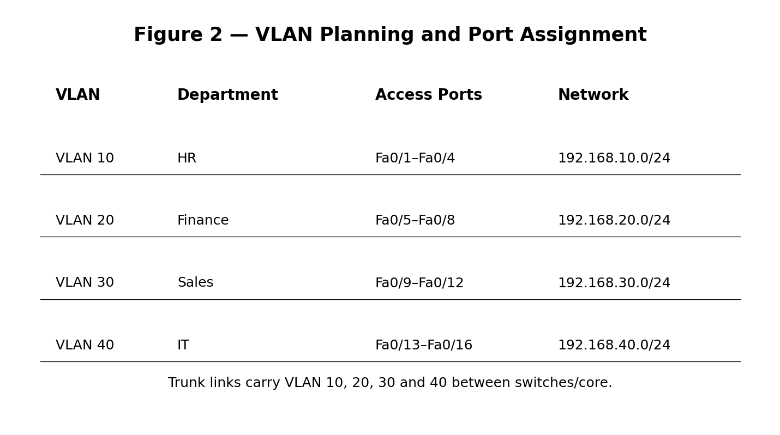

4. Cisco Packet Tracer – Step-by-Step Implementation

Step 1 – Open Packet Tracer and place devices
- Open Cisco Packet Tracer.
- Add one 3560 multilayer switch as the central/core switch.
- Add four 2960 switches for HR, Finance, Sales, and IT.
- Add one 2911 router for external connectivity.
- Add at least two PCs under each department switch.

Step 2 – Connect the devices
- Use Copper Straight-Through cables for PC-to-switch connections.
- Connect each department switch to the central multilayer switch.
- Use a Gigabit Ethernet link where available for switch uplinks.
- Connect the central switch to the router.
- Use clear labels such as HR-SW, FIN-SW, SALES-SW and IT-SW.

Step 3 – Create VLANs on the switches
- Open the central switch CLI.
- Create VLAN 10 and name it HR.
- Create VLAN 20 and name it FINANCE.
- Create VLAN 30 and name it SALES.
- Create VLAN 40 and name it IT.

Step 4 – Assign access ports
- On each department switch, configure the PC-facing ports as access ports.
- Assign HR PC ports to VLAN 10.
- Assign Finance PC ports to VLAN 20.
- Assign Sales PC ports to VLAN 30.
- Assign IT PC ports to VLAN 40.

Step 5 – Configure trunk links
- Configure the uplink from each access switch as a trunk.
- Configure the corresponding central-switch ports as trunks.
- Allow VLANs 10, 20, 30 and 40 on the trunk.
- Verify the trunk using the show interfaces trunk command.
- Correct any port/VLAN mismatch before testing.

Step 6 – Configure inter-VLAN routing
- Enable IP routing on the multilayer switch.
- Create SVI interface VLAN 10 with gateway 192.168.10.1.
- Create SVI interface VLAN 20 with gateway 192.168.20.1.
- Create SVI interface VLAN 30 with gateway 192.168.30.1.
- Create SVI interface VLAN 40 with gateway 192.168.40.1.

Step 7 – Configure PC IP addresses
- Open each PC and select Desktop → IP Configuration.
- Enter the IP address according to its department.
- Use subnet mask 255.255.255.0.
- Enter the matching VLAN gateway as Default Gateway.
- Repeat the process for all PCs.

Step 8 – Configure router connectivity
- Connect the multilayer switch to the router.
- Assign an IP address to the Layer 3 link.
- Configure the router interface with an IP address in the same subnet.
- Use a default route on the multilayer switch toward the router.
- Use appropriate routing/NAT configuration if Internet simulation is added.

Step 9 – Test and validate
- From an HR PC, ping 192.168.10.1.
- From Finance, ping 192.168.20.1.
- From Sales, ping 192.168.30.1.
- From IT, ping 192.168.40.1.
- Test HR-to-Finance and other inter-VLAN pings to confirm routing.
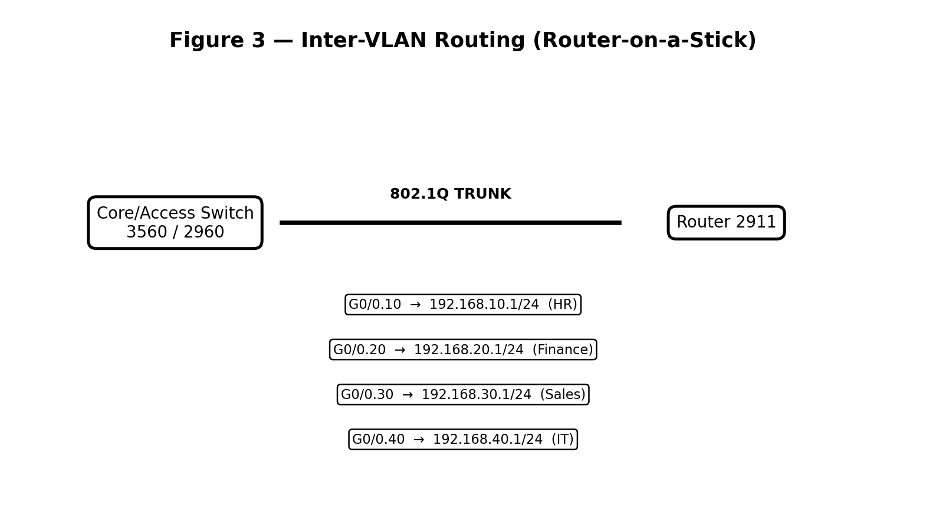

5. Sample Cisco IOS Configuration
! Core multilayer switch
enable
configure terminal
vlan 10
name HR
vlan 20
name FINANCE
vlan 30
name SALES
vlan 40
name IT
ip routing
interface vlan 10
ip address 192.168.10.1 255.255.255.0
no shutdown
interface vlan 20
ip address 192.168.20.1 255.255.255.0
no shutdown
interface vlan 30
ip address 192.168.30.1 255.255.255.0
no shutdown
interface vlan 40
ip address 192.168.40.1 255.255.255.0
no shutdown
! Example trunk uplink
interface gigabitEthernet0/1
switchport mode trunk
switchport trunk allowed vlan 10,20,30,40
no shutdown
end
write memory

6. Five-Point Explanation for Each Screenshot

Screenshot 1 – Complete topology
- Shows the central Layer 3 switch connected to four department switches.
- Shows separate end devices for HR, Finance, Sales, and IT.
- Demonstrates the star/hierarchical structure used for manageability.
- Shows the router connected to the central switching layer for external access.
- Provides visual evidence that the planned network has been physically implemented.

Screenshot 2 – VLAN configuration
- Shows VLAN 10 for HR and VLAN 20 for Finance.
- Shows VLAN 30 for Sales and VLAN 40 for IT.
- Demonstrates logical separation of departments.
- Reduces unnecessary broadcast traffic between departments.
- Provides the VLAN structure required for secure inter-department networking.

Screenshot 3 – Inter-VLAN routing
- Shows the Layer 3 gateway for each department.
- Each SVI uses a different /24 network.
- The multilayer switch routes traffic between VLANs.
- 802.1Q trunking carries multiple VLANs across one uplink.
- This allows controlled communication between different departments.

Screenshot 4 – Testing and validation
- Shows successful gateway ping from each department.
- Confirms that IP addressing and subnet masks are correct.
- Inter-VLAN ping verifies that Layer 3 routing is working.
- Testing helps identify cable, VLAN, gateway, or routing errors.
- Successful tests provide evidence that the network is functional.
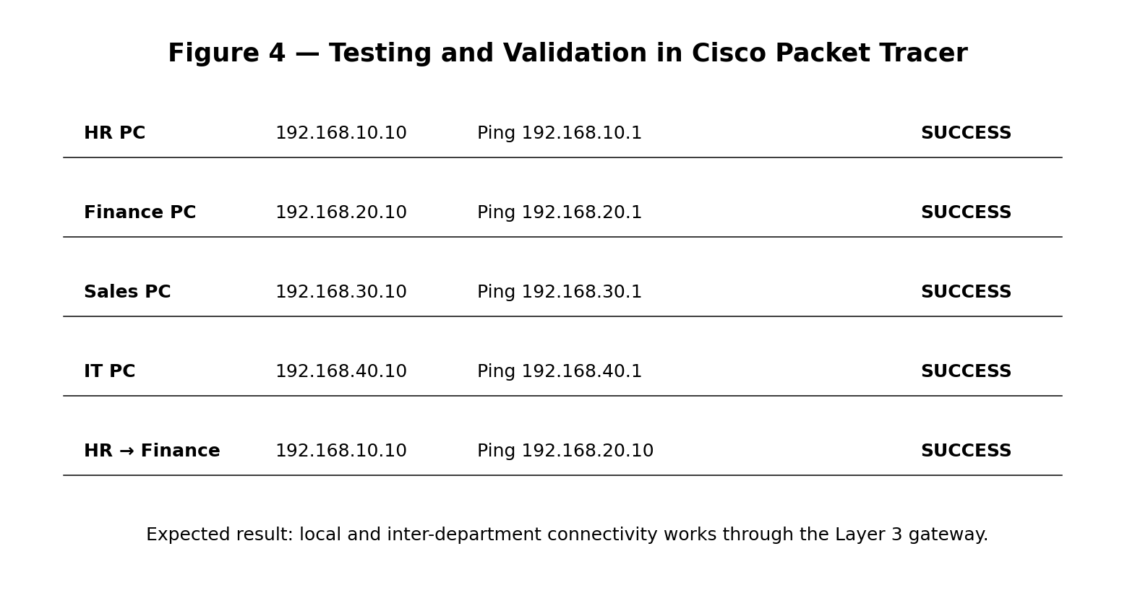

7. Testing and Validation Table
Test | Source | Destination | Expected Result
Gateway test | HR PC | 192.168.10.1 | Success
Gateway test | Finance PC | 192.168.20.1 | Success
Gateway test | Sales PC | 192.168.30.1 | Success
Gateway test | IT PC | 192.168.40.1 | Success
Inter-VLAN test | HR PC | Finance PC | Success
Inter-VLAN test | Sales PC | IT PC | Success

8. Problem-Solving Approach
- Analyze the company requirement and identify departments as separate logical networks.
- Choose VLANs to isolate departments and reduce broadcast traffic.
- Use Layer 2 switches at the access layer for end devices.
- Use a Layer 3 switch/router for inter-VLAN routing and external connectivity.
- Test connectivity and verify VLANs, trunks, gateways, and routing before deployment.

9. Security, Reliability and Scalability
- Finance and HR can be isolated using VLANs and access-control policies.
- Unused switch ports can be disabled to reduce unauthorized access.
- Port security can be enabled on access ports where required.
- Redundant uplinks can be added for important departments.
- Additional departments can be added by creating new VLANs and subnets without redesigning the whole network.

10. Advantages of the Proposed Design
- Improved security through VLAN-based logical separation.
- Reduced broadcast traffic and better network performance.
- Centralized management through the Layer 3 core switch.
- Easy troubleshooting because departments are logically separated.
- Scalable architecture suitable for future departments and additional users.

11. Conclusion
The proposed departmental network uses a hierarchical design with Layer 2 access switches, a central Layer 3 switch, VLANs, inter-VLAN routing, and a router for external connectivity. The design improves security, performance, reliability, and scalability. Cisco Packet Tracer can be used to implement and validate the design before physical deployment, reducing configuration errors and deployment cost.

Submission note: Replace the four illustrative figures with your own Cisco Packet Tracer screenshots if your faculty specifically requires screenshots from the Packet Tracer application.

